AI Assisted Coding End Lab Exam 20.11.2025 CSB01 and CSB02
📘 SET 4
Q1. Data Structures (Scenario)
A food delivery app stores customers' recent searches. Implement a Stack where latest search appears first. (Include documentation + test cases.)
Q2. Algorithms (Scenario)
A logistics company wants to sort parcel weights quickly. Use AI to implement Merge Sort to sort millions of weight entries. (Add docs + comments + tests.)

TASK_1 :
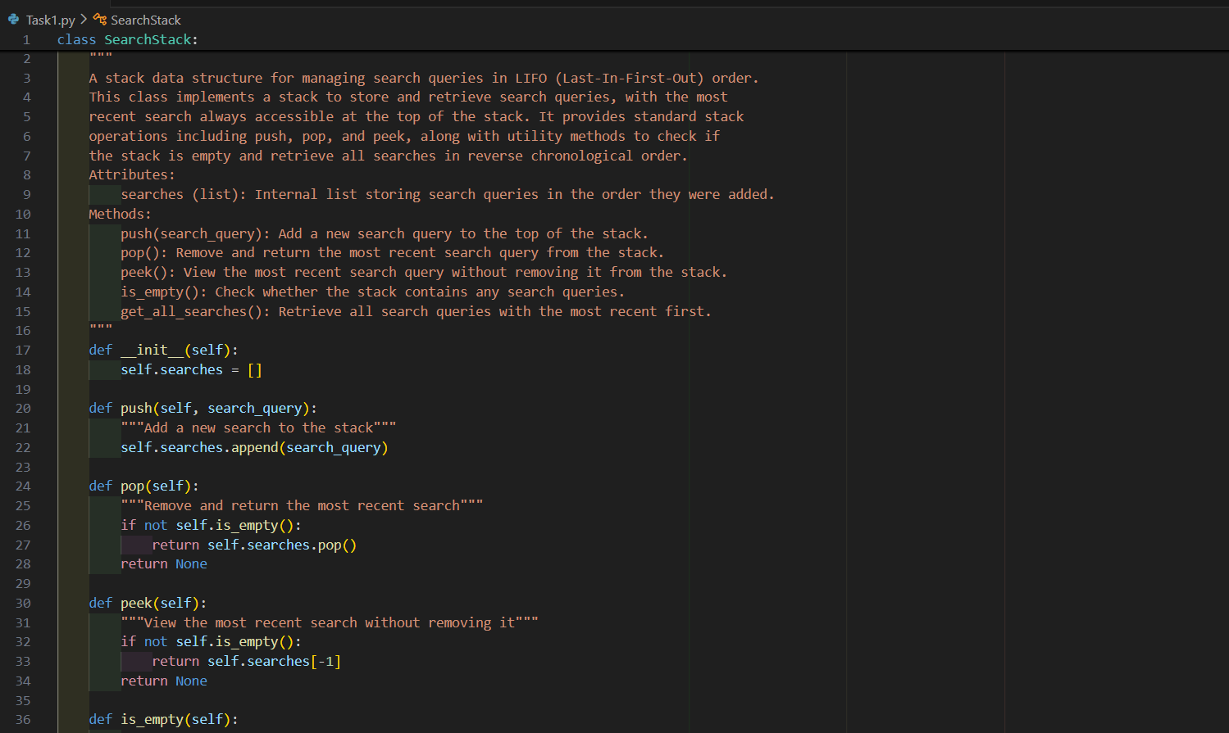
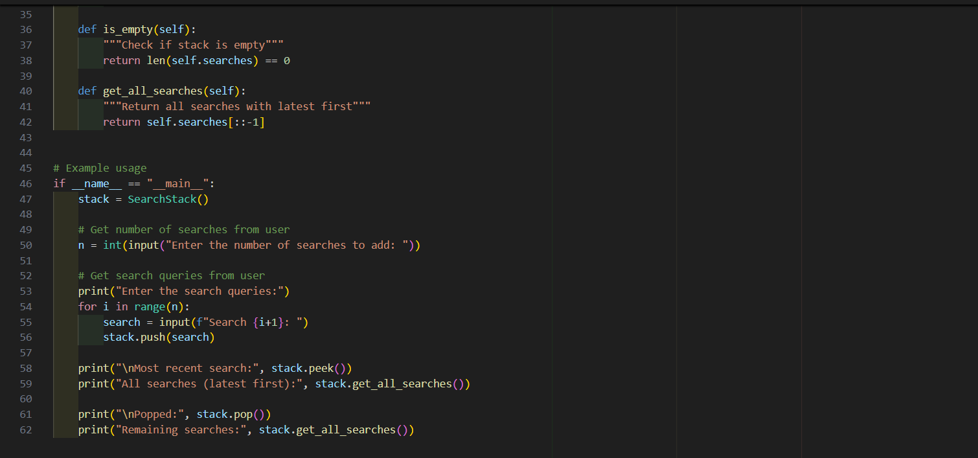
OUTPUT :
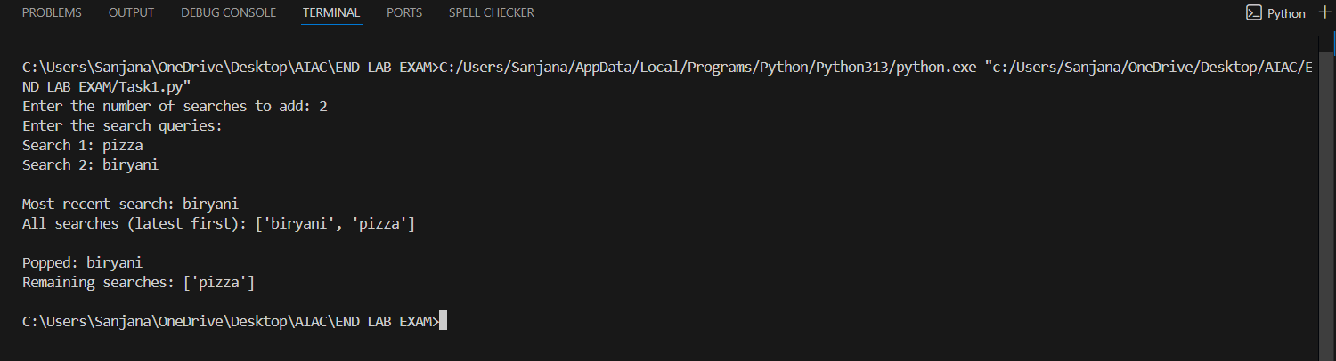
TEST CASE 1 :
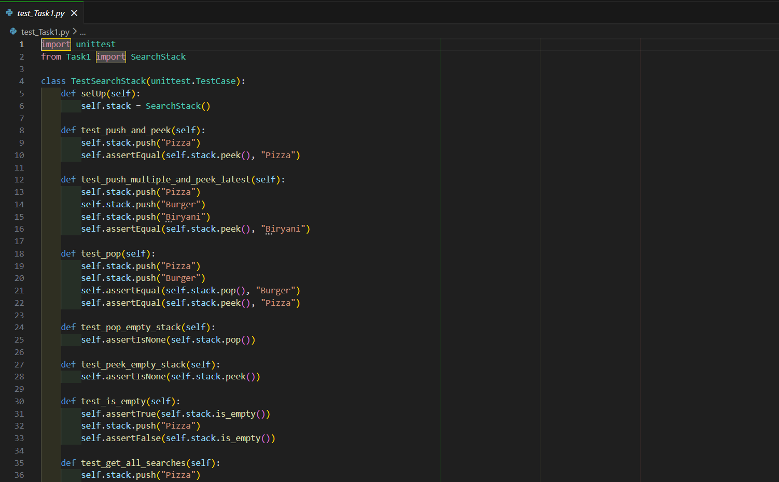
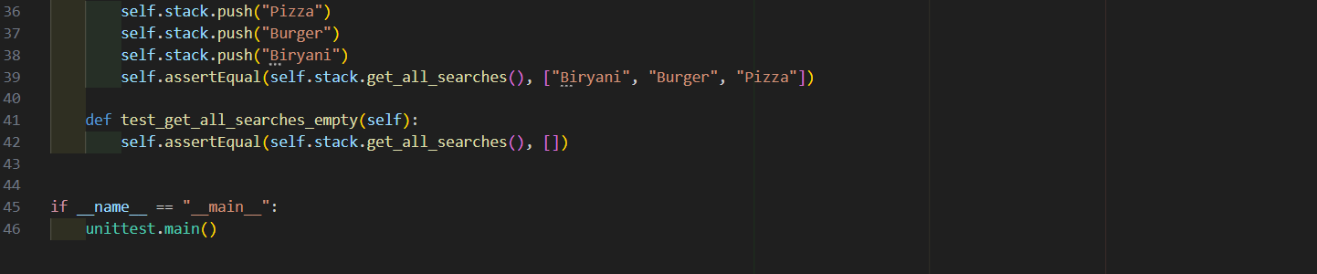
OUTPUT :
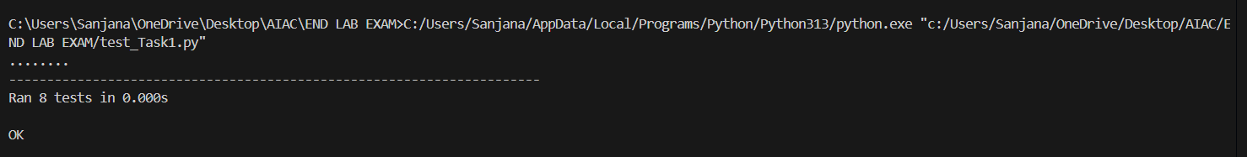

TASK 2 :
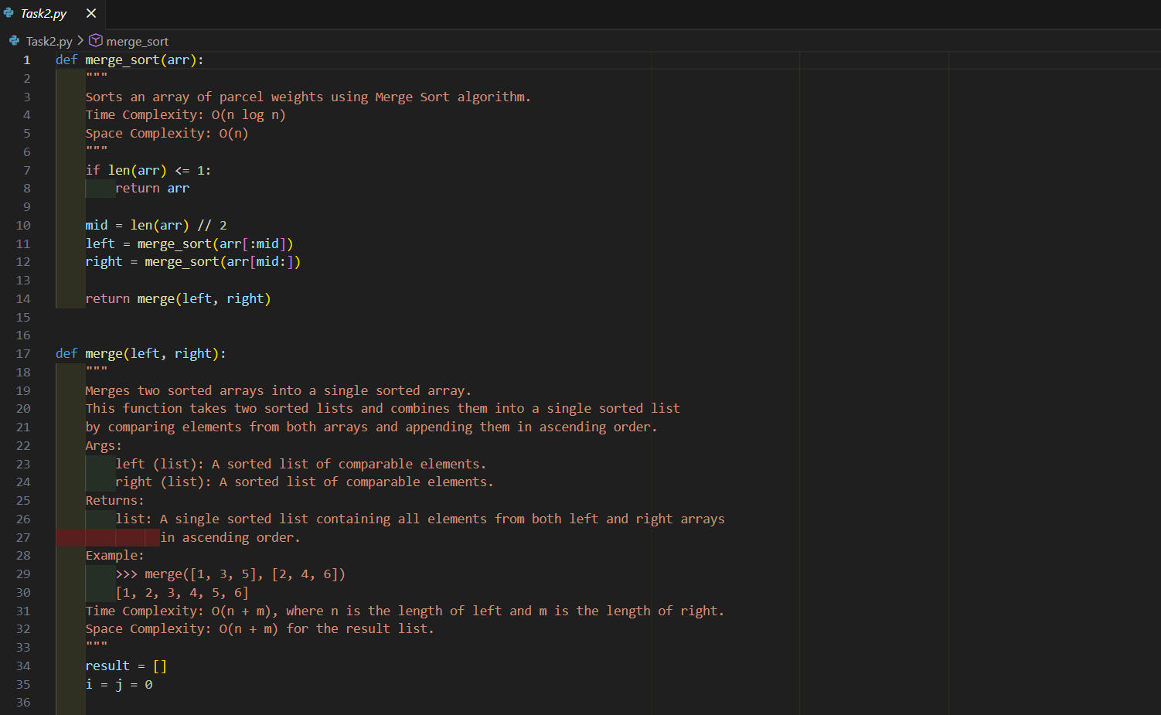
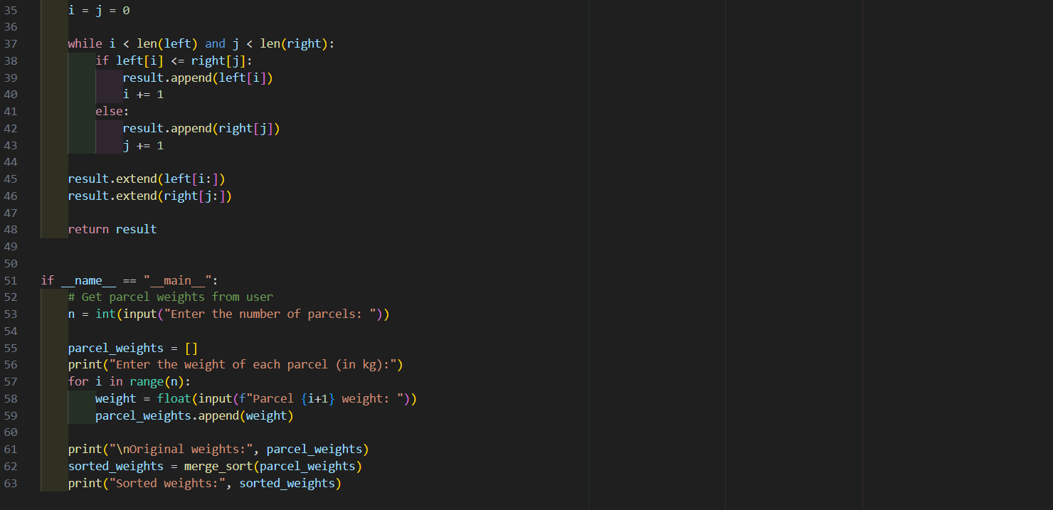
OUTPUT :
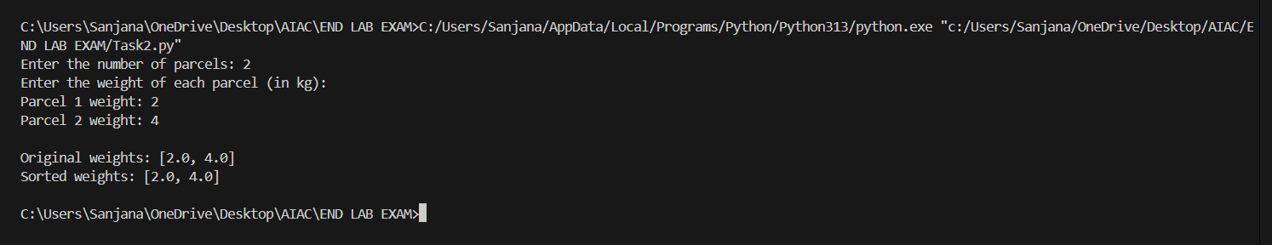

TEST CASE 2 :
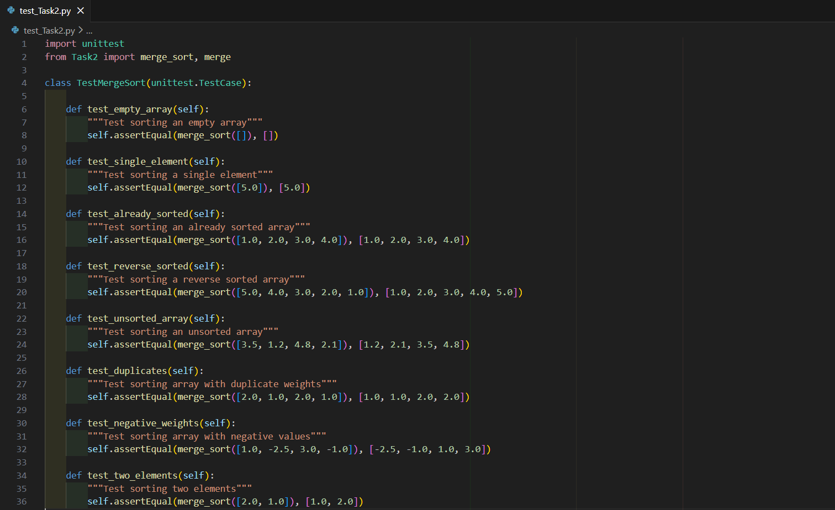
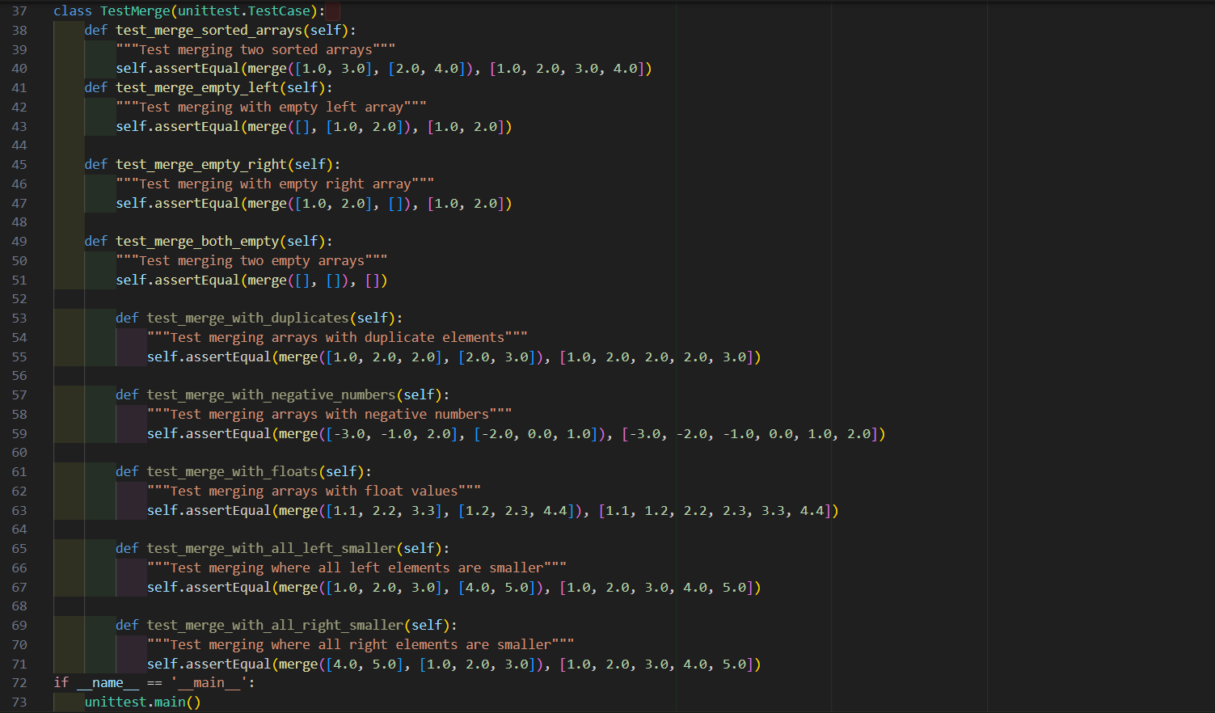
OUTPUT :
